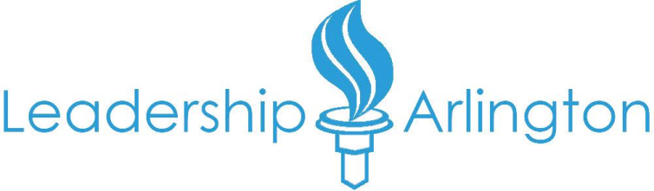
PRESS RELEASE  FOR IMMEDIATE RELEASE  October 1, 2012 | Contact: Jenn Oribello  Program Manager  Leadership Arlington  4420 N. Fairfax Drive, Suite 102  Arlington, VA 22203  703-528-2522  joribello@leadershiparlington.org
Leadership Arlington Welcomes 39
Young Professionals to Membership
Arlington, VA - On Saturday, September 29, Leadership Arlington's newest class of the Young Professionals Program gathered for the first time at a day-long retreat at Marymount University. Thirty-nine talented individuals were selected to participate in an experiential program, now in its third year, for emerging leaders in the region. The new class joins Leadership Arlington's 800 members representing over 500 organizations.

"The program is designed to help our young professionals develop strong ties, open the door to deeper engagement within the civic and philanthropic landscape, and plant roots within the Northern Virginia, Maryland and Washington, DC communities," says Liz Nohra, Chief Operating Officer at Leadership Arlington.

"By connecting them with local leaders, we encourage participants to broaden their perspectives and feel motivated to affect change in their professional, civic and volunteer endeavors," says Betsy Frantz, President and CEO at Leadership Arlington.

Over the next four months, the Young Professionals Program will focus on civic and philanthropic awareness along with community engagement. In addition to these program goals, they will receive valuable leadership skills training.

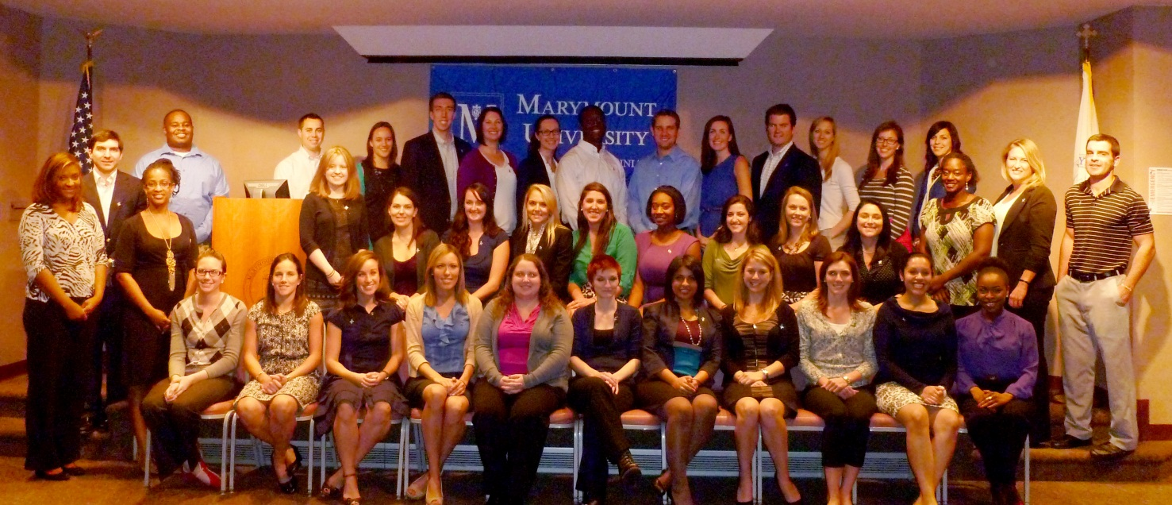

Congratulations to the Leadership Arlington
Young Professionals Program Class of 2013!

Allison Alt, Year Up National Capital Region
Cassie Bate, Columbia Pike Revitalization Organization
Kelsie Bathurst, Virginia Hospital Center
Ayana Bellamy, A-SPAN
Claire Bordley, The Shooshan Company
Laurie Calzadilla, Technomics Inc.
Angela Camp, Technomics Inc.
Megan Caposell, SRA International
Sarah Daviau, Arlington Public Library
Ben Davis, Marymount University
Stephanie Gordon, Aegis LLC
Brandy-Michelle Hart, Deloitte & Touche LLP
Ifiok Inyang, Booz Allen Hamilton
Mary Johnson, ESI International
Angela Kasey, Long & Foster Real Estate, Inc.
Tripp Kelly, III, Northwestern Mutual Financial Network
Allie Krafft, Ballston Business Improvement District
Allison Lewis, Arlington Community Foundation
Renee Mayo, Artisphere
Liz McElwee, APAH
Lee Anne McLarty, Rosslyn BID
Kaitlyn Mulvey, The JBG Companies
Koube Ngaaje, AFAC
Jon Puvak, Walsh Colucci Lubeley Emrich & Walsh, P.C.
Melvin Reed, Arlington County Fire Department
Ken Rhodes, Technomics, Inc.
Christine Rossini, Healthcare Distribution Management Association
Alejandra Santaolalla, National Abortion Federation Hotline Fund
Erin Schlesing, Marymount University
Jackie Sims, Wolf Trap Foundation for the Performing Arts
Ashlin Smith, Technomics, Inc.
Grelia Soliz, Arlington County Government
Kristen Sweet, Washington Workplace
Amy Thomas, Arlington Community Federal Credit Union
Darren Tully, Virginia Heritage Bank
Brittany Van Arkel, PDRI
Leslie Welch, Healthcare Distribution Management Association
Cora Widmayer, Deloitte & Touche LLP
Matt Wurster, Clark Construction Group LLC
About Leadership Arlington

The mission of Leadership Arlington is to enlighten, inspire and connect leaders to strengthen the community. The vision of Leadership Arlington is a prepared, inspired and inclusive Arlington leadership who together embrace responsibility for the common good. For more information, visit www.leadershiparlington.org or call 703-528-2522.

# # #

