Leadership Arlington CEO Receives National Recognition

Arlington, VA - Betsy Frantz, President and CEO of Leadership Arlington, recently
received national recognition for her outstanding contributions to the Arlington community with the prestigious "Preceptor Award," given by the Association of Leadership Professionals (ALP).

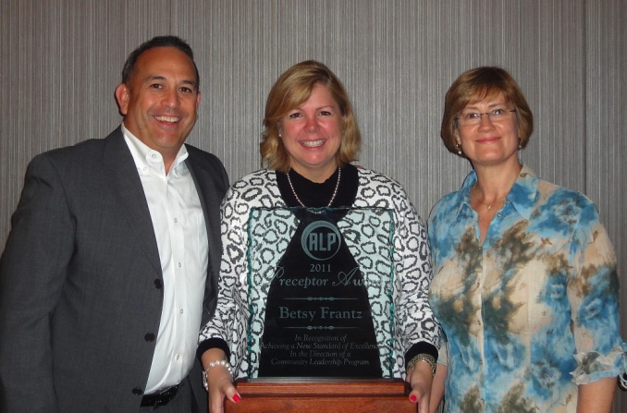
Betsy Frantz accepted the Preceptor Award in Dallas joined by Leadership Arlington Board of Regents members John Murphy '99 of Washington Workplace, and Marty Almquist '99 of Avison Young.
This award goes to the head of a community leadership organization who has "achieved a new standard of excellence." The recipients of the Preceptor Award are "leaders among leaders" chosen from hundreds of submissions throughout the country.

"Preceptors are individuals with a level of expertise making them capable of lending guidance to others," said Griff Hall, ALP's Board Chair.

Under Betsy's guidance as the founding CEO since 1998, Leadership Arlington's membership has grown to include over 700 key leaders who represent more than 500 organizations in the Arlington area.

"Betsy's ability to envision change and growth has been one of the hallmarks of her leadership, and has greatly affected Leadership Arlington's success as a thriving resource in the region," said Robin Norman, Senior VP/CFO of Virginia Hospital Center and Chair of Leadership Arlington's Board of Regents. "She has ensured that every decision is mission-driven and provides value to the membership and to the community."

Following her acceptance of the Preceptor Award, Betsy was asked to join the board of the Association of Leadership Professionals.

Betsy's experience in a host of local community organizations reflects proven achievement in leadership, facilitation, strategic organizational planning and development, fundraising, negotiation, coalition building and volunteer activism. Read her complete biography here.

